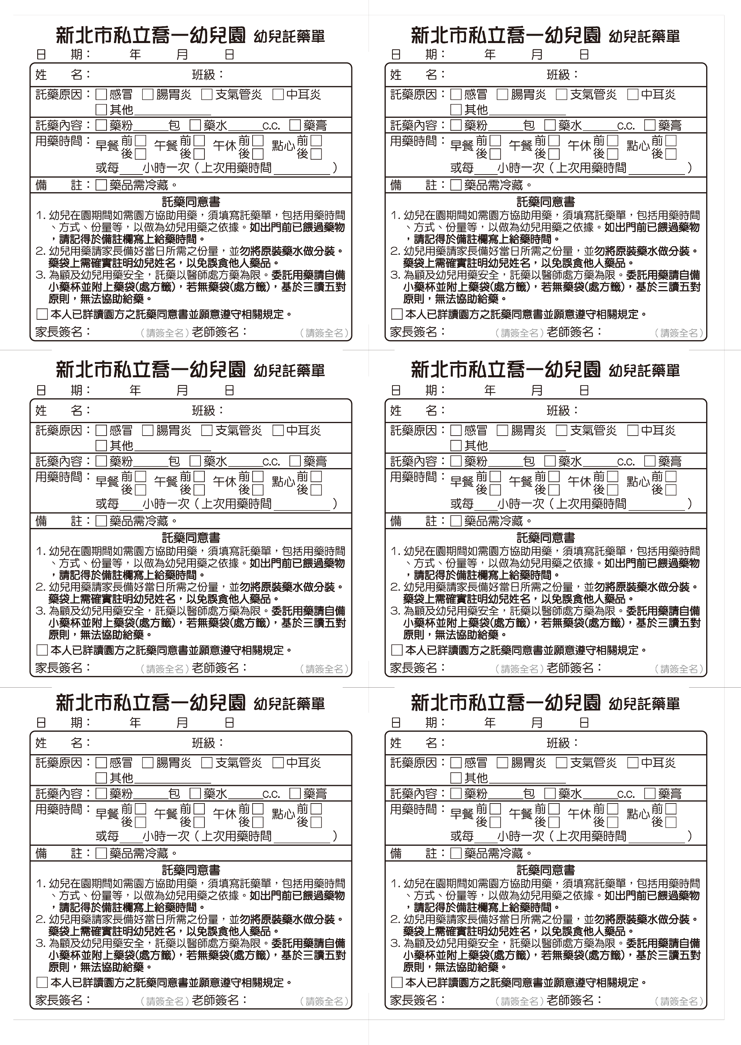
Cherry Class
Cherry Class
Cherry Class
Cherry Class
Cherry Class
Cherry Class

